**Google 职位薪资与package参考**

[](http://www.jiuzhang.com/)

本资料由九章算法独家倾情整理

[www.jiuzhang.com](http://www.jiuzhang.com)

**目录**

1. Google 内部职级 (SDE) 2

2. Google各职位薪资情况 2

3. Google offer包裹参考 3

拿谷歌 offer 必备课程

《[面试软技能指导 - BQ/Resume/Project](https://www.jiuzhang.com/course/21/?utm_source=sc-libao-facebook)》《[九章算法班](https://www.jiuzhang.com/course/1/?utm_source=https:/www.jiuzhang.com/course/21/?utm_source=sc-libao-facebook)》《[⾯向对象设计OOD](https://www.jiuzhang.com/course/40/?utm_source=https:/www.jiuzhang.com/course/21/?utm_source=sc-libao-facebook)》

《[系统设计System Design](https://www.jiuzhang.com/course/28/?utm_source=https:/www.jiuzhang.com/course/21/?utm_source=sc-libao-facebook)》《[人工智能集训营](https://www.jiuzhang.com/course/20/?utm_source=https:/www.jiuzhang.com/course/21/?utm_source=sc-libao-facebook)》《[硅谷求职算法集训营](https://www.jiuzhang.com/course/29/?utm_source=https:/www.jiuzhang.com/course/21/?utm_source=sc-libao-facebook)》

## Google 内部职级 (SDE)

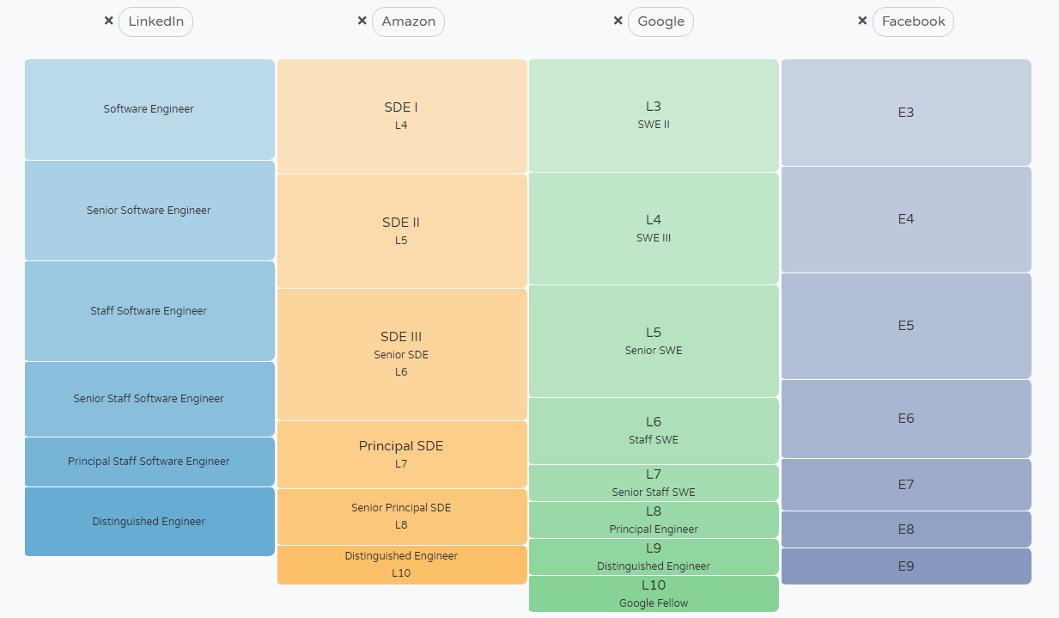

来源：levels.fyi

## 2. Google各职位薪资情况

|  |  |  |  |  |  |
| --- | --- | --- | --- | --- | --- |
| **职位** | **Levels** | **Total** | **Salary** | **Stock(/yr)** | **Bonus** |
| SWE II | L3 | 181,842 | 120,842 | 41,093 | 19,907 |
| SWE III | L4 | 256,449 | 148,116 | 79,082 | 29,251 |
| Senior SWE | L5 | 343,243 | 178,146 | 128,967 | 36,130 |
| Staff SWE | L6 | 472,600 | 208,000 | 197,286 | 67,314 |
| Senior Stuff SWE | L7 | 638,150 | 257,700 | 296,650 | 83,800 |
| Manager (SEM) | L6 | 475,055 | 215,500 | 211,222 | 48,333 |
| Senior Manager(SEM) | L7 | 749,600 | 260,400 | 414,000 | 75,200 |

## 3. Google offer包裹参考